

**Markov Model Project**

Mariem Haggag 52-11236

Jana El-Orashy 52-2384

Ahmed El Wassif 52-0267

Mohamed Sherif52-0982

Mostafa El feel 52-6675

**Introduction:**

Customer churn, the rate at which customers stop doing business with a company, poses challenges due to complex data, multi-faceted causes, and difficulty in prediction. It is important because it impacts revenue, customer lifetime value, brand reputation, and provides market insights. To address this problem, companies employ a methodology that involves data collection and analysis, predictive modeling, customer feedback, intervention strategies, and ongoing monitoring to reduce churn and sustain business growth.

**Dataset choice**:

We had to choose an appropriate dataset according to several factors, we wanted a data set that is related to customer churn but still has attributes that affect customer churn and can easily track it.We decided to choose the business problem of customer churn and our data set was specifically about customer churn in the telecommunications industry. It has the usability of 8.24 and refers to a fictitious telecommunications firm that, in Q3, offered residential phone and Internet services to 7043 clients in California. It shows which clients have unsubscribed, stayed, or joined their service. For each customer, several significant demographics are supplied. Several attributes like type of contract( month to month, one year, two year) , senior citizen( yes or no) whether the line has internet or not and many more were present in our data set. These attributes are severely important for our model. We thoroughly examined our dataset and the columns highlighting which attribute affected the customer churn in our dataset and we found a pattern and a relation between customer churn and contract type.

**Types of variables and predictions**

After determining the Customer churn dataset, we have chosen the variable contract to be the dependent variable and the customer churn would be the independent variable. After constructing the code to see how the contract types would affect the churn we have come with this graph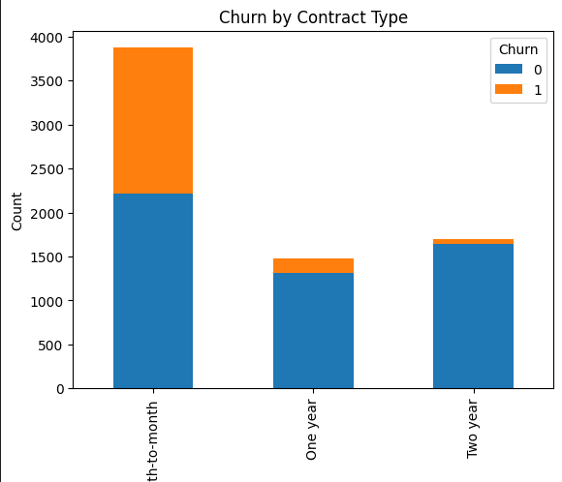

The "Contract Type" on the x-axis, "Churn" counts on the y-axis, and for each "Contract Type," there will be stacked bars representing the count of "Churn" for different categories, such as Month-to-month, One year, and Two years. This visualization will allow us to see how Churn is distributed across different contract types.

After that , we have made a code in order to develop a markov model.We extracted the current state from the Contract column and the next state from the Churn column.  
After that , we have checked if the current state is already in the dictionary of the markov model and. If not, we have created an entry for it and initialized a nested dictionary with the next state and set its count to 1. If the current state is already in the model, we check if the next state is in the nested dictionary. If it is, we increment the count; otherwise, we create an entry for the next state and set its count to 1. After iterating through the data, we calculated transition probabilities by dividing the count of each next state by the total count for that current state. This step transforms the counts into probabilities.we have printed the following information: The number of states, which corresponds to the number of unique "Contract" states in your data.The transition probabilities for Month-to-month contracts, One year contracts, and Two-year contracts.

We finally came up with these probabilities:

number of states = 3 Month-to-month: {'No': 0.5729032258064516, 'Yes': 0.4270967741935484} One year: {'No': 0.8873048200950441, 'Yes': 0.11269517990495587} Two year: {'No': 0.9716814159292035, 'Yes': 0.02831858407079646}

**We have found that :**

**Three month to month contracts:**

The Probability of churning (Yes): approximately 42.71% while the probability of not churning (No)is approximately 57.29%.

This predicts that customers with "Month-to-Month" contracts have a significant likelihood of churning (leaving), with about 42.71% of them expected to churn.

**One-Year Contracts:**

The Probability of churning (Yes)is Approximately 11.27% and the probability of not churning (No)is Approximately 88.73%.

This predicts that customers with "One-Year" contracts have a lower likelihood of churning compared to "Month-to-Month" customers, with only about 11.27% expected to churn.

**Two-Year Contracts:**

The Probability of churning (Yes) is approximately 2.83% while the Probability of not churning (No): Approximately 97.17%.

This predicts that customers with "Two-Year" contracts have a very low likelihood of churning, with only about 2.83% expected to churn.

This is a good prediction as when the period of customers increases the customer churn would decrease.